SECTION 1 : DDL (DATA DEFINITION LANGUAGE)
QUESTION 1 - CREATE TABLE
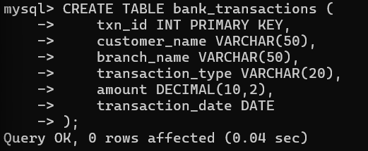
OUTPUT:
Table BANK_TRANSACTIONS created successfully.
QUESTION 2 - ALTER TABLE ADD COLUMN
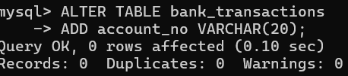
OUTPUT:
Table altered successfully.
QUESTION 3 - ALTER TABLE MODIFY COLUMN
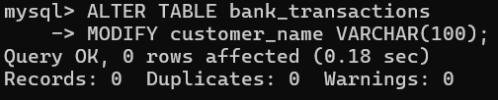
OUTPUT:
Column modified successfully.
QUESTION 4 - RENAME TABLE
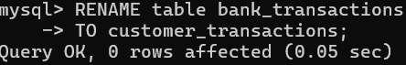

OUTPUT
Table renamed successfully.
QUESTION 5 - TRUNCATE TABLE
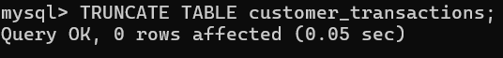
OUTPUT:
All rows deleted.
Table structure remains.
SECTION 2 : DML (DATA MANIPULATION LANGUAGE)
STEP 1 : INSERT SAMPLE DATA
